**Practical No: 1** **Date:** 21/07/2023

**Title:** Write a C++ program using functions to convert decimal to any base and vice versa.

**Description:**

The general form of a C++ function definition is as follows −

*return_type function_name( parameter list ) {*

*body of the function*

*}*

A C++ function definition consists of a function header and a function body. Here are all the parts of a function −

* Return Type − A function may return a value. The return_type is the data type of the value the function returns. Some functions perform the desired operations without returning a value. In this case, the return_type is the keyword void.
* Function Name − This is the actual name of the function. The function name and the parameter list together constitute the function signature.
* Parameters − A parameter is like a placeholder. When a function is invoked, you pass a value to the parameter. This value is referred to as actual parameter or argument. The parameter list refers to the type, order, and number of the parameters of a function. Parameters are optional; that is, a function may contain no parameters.
* Function Body − The function body contains a collection of statements that define what the function does.

**Program Code:**

**#include <stdio.h>**

**#include <math.h>**

**int bi_to_dec(int n);**

**int dec_to_bi(int decimalNum);**

**int oct_to_dec(int octalNum);**

**int dec_to_oct(int decimalNum);**

**int main()**

**{**

**int c,input;**

**printf("Menu: \n");**

**printf("1. Binary to decimal\n");**

**printf("2. Decimal to Binary\n");**

**printf("3. Octal to Decimal\n");**

**printf("4. Decimal to Octal\n");**

**printf("Enter option number: ");**

**scanf("%d",&c);**

**switch(c)**

**{**

**case 1:**

**{**

**printf("enter Binary Value: ");**

**scanf("%d",&input);**

**printf("Decimal value: %d",bi_to_dec(input));**

**break;**

**}**

**case 2:**

**{**

**printf("enter Decimal Value: ");**

**scanf("%d",&input);**

**printf("Binary value: %d",dec_to_bi(input));**

**break;**

**}**

**case 3:**

**{**

**printf("enter Octal Value: ");**

**scanf("%d",&input);**

**printf("Decimal value: %d",oct_to_dec(input));**

**break;**

**}**

**case 4:**

**{**

**printf("enter Decimal Value: ");**

**scanf("%d",&input);**

**printf("Octal value: %d",dec_to_oct(input));**

**break;**

**}**

**default:**

**{**

**printf("Wrong Choice!\n");**

**break;**

**}**

**}**

**return 0;**

**}**

**int bi_to_dec(int n )**

**{**

**int dec = 0, i = 0, rem;**

**while (n != 0) {**

**rem = n % 10;**

**n /= 10;**

**dec += rem * pow(2, i);**

**++i;**

**}**

**return dec;**

**}**

**int dec_to_bi(int decimalNum)**

**{**

**int binaryNum = 0;**

**int base = 1;**

**while (decimalNum > 0) {**

**int remainder = decimalNum % 2;**

**binaryNum += remainder * base;**

**decimalNum = decimalNum / 2;**

**base *= 10;**

**}**

**return binaryNum;**

**}**

**int oct_to_dec(int octalNum)**

**{**

**int decimalNum = 0;**

**int base = 1;**

**while (octalNum > 0) {**

**int remainder = octalNum % 10;**

**decimalNum += remainder * base;**

**octalNum = octalNum / 10;**

**base *= 8;**

**}**

**return decimalNum;**

**}**

**int dec_to_oct(int decimalNum)**

**{**

**int octalNum = 0;**

**int base = 1;**

**while (decimalNum > 0) {**

**int remainder = decimalNum % 8;**

**octalNum += remainder * base;**

**decimalNum = decimalNum / 8;**

**base *= 10;**

**}**

**return octalNum;**

**}**

**Input and Output**

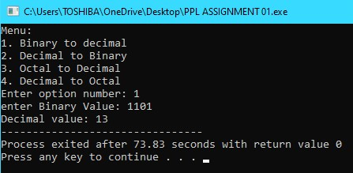 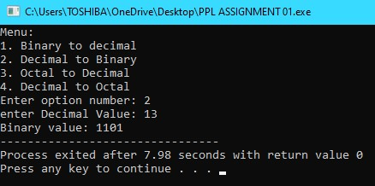 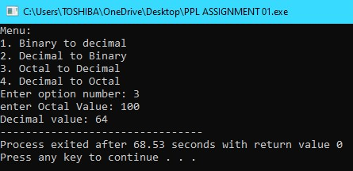 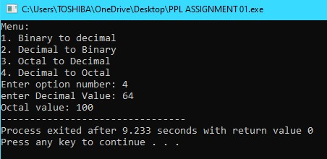

**Conclusion:** Thus we have implemented the functions in C++.

**Practice programs:**

1. Write a program to convert decimal to Fahrenheit using functions.
2. Write a function to calculate GCD and LCM of the numbers entered.
3. Write a program to calculate different statistics of the data entered like mean, median etc. using functions.